Greene County Family Planning
2012 Annual Report

2012 was a year of great effort and change for the staff of Greene County Family Planning. There were changes in staffing and personnel, a changeover to electronic medical records, an audit by the NY State Health Department, and continued fiscal tightening from the County. For several years in a row Greene County Family Planning has seen an increase in the numbers of persons at or below 100% of the federal poverty level. Currently 89% of our clients are at this Federal Poverty level- up from 87% in 2011. Despite the challenges, staff was successful in fulfilling the mission of providing Comprehensive Reproductive Health care for the women and men in our community, and our program continued to grow in its number of clients served, our revenue and the number of educational presentations in the community.

In 2012 we had four long term employees move on to retirement and other employment. They averaged 17 years working for Family Planning so their collective loss was a challenge for the clinic. Fortunately through promotions and hiring, we were able to find highly qualified staff that is doing excellent work. We have reduced one of our positions to part time, and that position remains unfilled at the current time.

Our hardworking staff includes: Board Certified Nurse Practitioners: Marianne Powers and Brenda Maccio, Public Health Nurse: Wendy Johnson, Health Educator: Jennifer Boland, Principal Senior Family Planning Aide: Kayla Eacott, Senior Family Planning Aides: Meghan Kelly and Tara Hall, Medical Receptionist: Charissa Bagley, and Account Clerk Typist: Dolores Boutin.

One full time Program Administrator/Nurse Practitioner oversees the clinic and provides Patient care, and our Medical Director, Dr. Lawrence Perl, provides onsite care to our clients, as well as, acting as a consultant to our Clinical Staff. The Patient Care Review committee meets monthly and consists of Dr. Perl and the three Nurse Practitioners. Dr. Perl performs a quality assurance review on four clients’ charts each quarter. In addition any cases the NP’s wish to review are discussed and a summary of his recommendations is charted in the medical record. Also discussed at the meeting are the findings of all of the Quality Assurance activities of the clinic, the collated results of the monthly client surveys, any policy and procedure updates, and recently released research articles.

Greene County Family Planning is also the Greene County provider of STD testing and treatment for Greene County residents. In 2012 there were 152 STD visits and 83 HIV tests performed. Currently those STD visits are provided free of charge but legislation is pending to change that in 2013. For the purposes of this report the remaining statistics are solely those of the Family Planning Clinic.

As Administrator I predicted in the fall of 2012 that we would be unable to meet our goal of seeing the same number of unduplicated Family Planning clients because of the impact of the above mentioned changes, however the staff prevailed and the unduplicated client count goal was surpassed.

In 2012, we saw 1153 unduplicated clients within our total of 2,580 Family Planning visits.

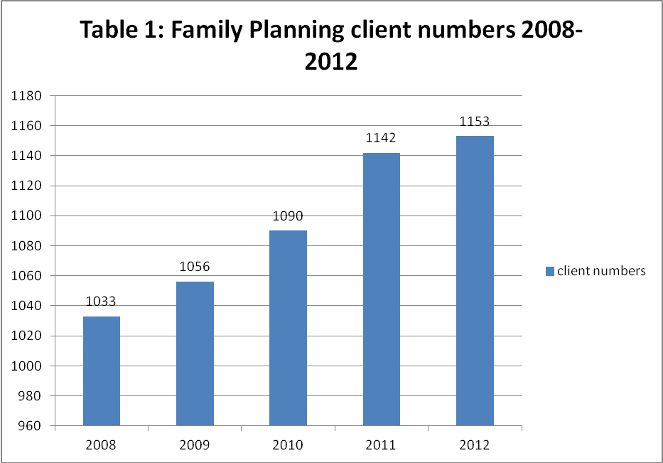

We were very pleased that in 2012 our third party revenue increased by 5.5%. This revenue is from billing private insurance, Medicaid and patients fees. Our Title X grant funding remained stable in 2012. Also in 2012 we began taking credit cards at the front desk to allow our clients to pay for their current visit charges and overdue accounts. We were pleased that we were able to provide this service to our clients and in turn it has allowed us to garner more revenue than we otherwise would have. A small convenience fee is charged to the client with their upfront consent which eliminates Family Planning incurring additional costs.

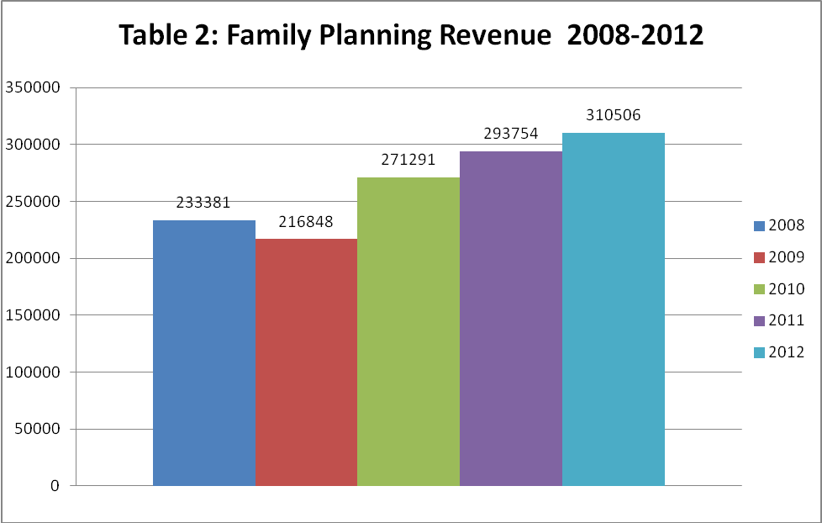

In 2012 we installed Medent, an electronic medical management record system including practice management, electronic billing software, and the electronic health record. Medent is used for all of our clients: Family Planning, STD and Cancer Services.

The challenges were great and included:
- the buy in from staff to implement this change
- the downtime that the training took
- the time it took to learn the new technology and become proficient as well as
- the impact it had on our ability to see the same numbers of clients

Though still in its early stages, the system has improved our ability to provide the following to our clients:
- the capability of sending all scripts electronically reducing errors
- Disease management reminder cues that pop up to indicate when a client is due for a Pap, mammogram, HIV test, rubella screening, Chlamydia for those under age 25, and clinic specific items we have created. We anticipate this to be advantageous to providing comprehensive ongoing care.
- Easier communication between our practice and our clients’ primary care providers
- Reducing billing coding errors by producing legible visits summaries
- Providing all clients with a clinical visit summary complete with discharge instructions and educational handouts
- Standardization of what constitutes a level of service which enhances the ability for the NP’s to code the visit correctly.
- Increased efficiency by our billing staff resulting in a reduction of the numbers of returned claims and a subsequent increase in revenue

And most importantly, since we have certified that we have the electronic record and are actively using it, we will be receiving $65,000.00 in federal incentive reimbursement which will cover the costs of its purchase and training. As we move through years 2-6 and continue to achieve meaningful use, we will continue to receive incentive reimbursements up to $21,500 each calendar year. This money will be useful to offset the costs of maintaining and upgrading computer equipment and software necessary for the program.

At Family Planning we are tasked by the U.S. Office of Population Affairs, (from whom the Title X grant money is distributed at the federal level) to meet key public health objectives including:

1. Reducing unintended pregnancies and the need for abortions
2. Curbing the spread of STD’s and HIV
3. Improving birth outcomes
4. Facilitating early detection and treatment of breast, testicular, cervical and endometrial cancer.

In 2012 we continued to see our overall pregnancy rates fall as well as our teen pregnancy rate.

Table 3: Pregnancy rate by age 2008-2012

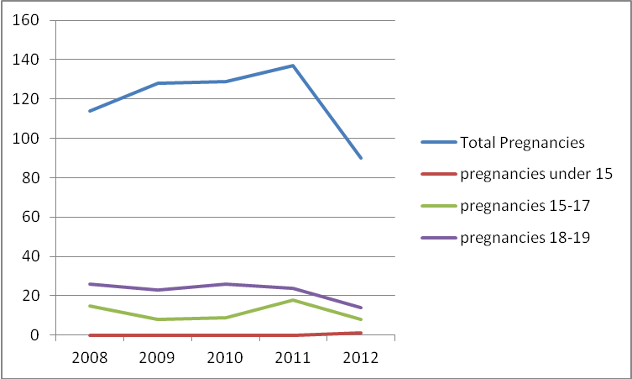

We attribute this to a keen awareness by all staff to recognize that Clients seeking to prevent pregnancy are counseled on the most effective birth control method possible. Looking at the graph below one can see that the numbers of clients with no method upon leaving the clinic has steadily fallen, as the number using a highly effective reversible method has steadily risen.

Table 4: Percent by type of contraceptives 2008-2012

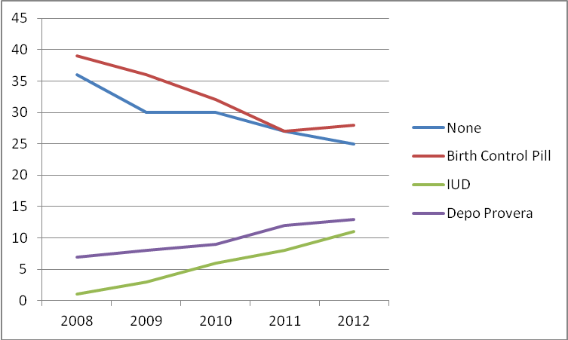

Family Planning statistics are gathered at each Family Planning visit. These are sent to a National data base which help the State and Federal government follow the outcome of the Title X money used by programs like ours. Each year a pregnancies’ averted number is calculated. For 2012, 172 pregnancies were estimated to be averted through our Family Planning Program

Curbing the spread of STD’s and HIV is achieved through routine testing for Chlamydia, Gonorrhea and HIV at each visit for at risk clients or at their annual exam. All pregnant clients and those at risk clients are also screened for syphilis and our clinic offers testing for herpes, human papilloma virus (HPV) and Hepatitis C for those with risk factors.

HIV and STD prevention is integrated in the Family Planning by being a core value in all of our settings. From the classroom where our health educator provides lessons on HIV and STD prevention to the community organizations where she educates on the topics of HIV and STD’s, prevention, it is always emphasized.
- All clinic clients receive HIV harm reduction counseling
- All clients are given the option to consent to an HIV test at their first visit and on an annual basis unless previously declined
- Medent disease management criteria in our new electronic records software system show a reminder pop up indicating when a client is due or overdue for an annual HIV test.
- Clients with high risk sexual behavior or those with current or previously diagnosed STD’s are encouraged to have more frequent testing.
- Every pregnant woman is strongly encouraged
- Our agency has informal linkage agreements with Albany Medical Center to provide referrals and care to all clients who test positive for HIV. In addition we partner with The Aids Council of Northeastern NY and the Aids Services of Catholic Charities of Columbia and Greene Counties to refer HIV positive clients for case management and any additional services they might need.

As the table below shows the incidence of Chlamydia and Gonorrhea, two sexually transmitted diseases have continued to rise over the past five years. We continue to educate our clients about the risks of STD’s and urge prevention strategies including abstinence, monogamous partnering and condom use.

Table 5: STD rates of treatment 2008-2012

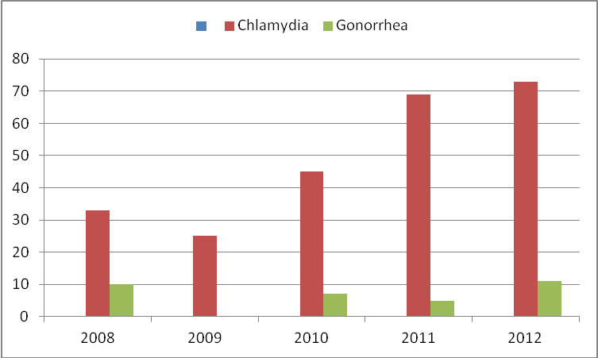

Improving Birth outcomes continues to be a goal at Greene County Family Planning. In June 2012 after a successful site review by the NYS Health Department, we were urged to more robustly screen for immunity to Rubella for all of our clients of childbearing age. In addition to that change we continue to offer pre-conception to all of our clients, and urge the cessation of drug use and alcohol before conceiving.

Facilitating early detection and treatment of breast, testicular, cervical and endometrial cancer continues to be a priority at Greene County Family Planning. In 2012 the screening intervals for the Pap smear, a test to detect cervical cancer, changed in accordance with new national guidelines issued by The American College of Obstetricians and Gynecologists. We continue to partner with the Cancer Services Program of Greene and Columbia counties to facilitate screening for breast, colon and cervical cancer for our uninsured women and men. Our Nurse Practitioners teach Breast Self Exam (BSE) and offer a clinical breast exam to all women but do not require it, thus removing a barrier to care and contraceptive initiation. We find that most women 21 and older consent to a breast exam and it is a good opportunity to teach about breast health and BSE. Family Planning clients between 40 and 50 are offered a yearly mammogram with the options given for them to make the decision. After aged 50 they are encouraged to have an annual mammogram.

Strategies that we implemented in 2012 or continue to provide to further our goal of prevention of pregnancy and STD’s and in keeping with our Title X goals are outlined below.

Adolescents:

- Adjusted our Walk in Teen Clinic Hours from 1-4:30 Thursdays to 3pm-6pm on Wednesdays, making it more feasible for students to visit outside of their normal school day. We have seen an increase in the numbers of teens accessing our services as a result of this change. Our new Health Educator continues the past practice of sending advertisements to all of the school nurses and health teacher contacts. She also developed a walk up board situated in the lobby of the county building advertising the Teen clinic times.
- Removed the barrier of a pelvic exam: our policies were updated in 2012 to remove the need for a Pelvic exam in order to start and or continue with contraception in accordance with 2012 ACOG guidelines. With the widespread availability of urine based screening, we can easily provide STD testing without a pelvic exam. Our clients are advised of the need for an exam if they are having symptoms of a vaginal infection that a urine GC and CT testing cannot screen for, if they have undiagnosed irregular bleeding or they are 21 and need their first Pap smear.
- Created new brochures entitled “The Male Exam” and the “First Pelvic Exam” and distributed to High School programs in an effort to help with the “fear” barrier which teens have in seeking reproductive care
- Comprehensive High School Sexual Health Programs are given in the 6 Greene County Schools
- Abstinence Education Program is given in Greene County Middle Schools
- A puberty Program is offered to 5th grade girls in Greene County Schools
- An evening Puberty Program for girls grades 4-6 accompanied by a significant female adult is given in a Greene County School.
- Made provisions to make improvements on our website so that it is more appealing and useful to teen population. This project in ongoing.
- Fashioned a press release during May as Teen Pregnancy Prevention Month

Males
- The Nurse Practitioner/Administrator at the invitation of the Windam Ashland Jewett School staffed a booth at a teen health fair where she taught about the testicular self exam and brought a model to teach and practice with.
- A new brochure called “The Male Exam’ was created and is distributed at H.S. and community based programs. This brochure spells out services for males at GCFP and also lessens the fear males have in seeking reproductive health care. It provides a play-by-play description of what takes place during a male exam.
- The updated Family Planning Clinic brochure now has a special section entitled Male Services.
- Various waiting room and easel displays target or include the male population.
- A section of the wall racks with brochures in the waiting room is specific to males.
- Added “The Impact of Fathers” to High School Lessons, Columbia Greene Community College, and Parenting classes which includes a video clip called “Knock-Knock”.
- A discussion about reproductive services for males, which include information about urine based STD testing, is included in H.S. and community based programs
- 6 lesson series of programs presented to the men at the Red Door Recovery Residence.
- There is a link on the GCFP website for Male Services.
- Males are educated about and encouraged to enroll in the FPBP program

Low income men and women

- Our Nurse Practitioner/Administrator staffed a free screening day hosted by the Rural Health Network in August 2012 where she performed Clinical breast exams to male and females who were interested. Two uninsured women with abnormal exams were referred to Cancer Screening Services for follow up mammography as a result of the screening day.
- The Family Planning Benefit Program is advertised in many venues including schools, colleges, health fairs, DSS, Probation and in many departments within the Greene County Office Building
- Programs are presented to DSS at the mandated Parenting classes, Twin County Recovery Services, Head Start Programs, and at Networking meetings to get the word out that “no one will be turned away” due to their inability to pay.
- Pull off tab signs are posted around town, including at the Hop-Nose Public Housing, a low income housing complex in Catskill, with our phone # and a list of services.
- High school and college students are taught about the services at GCFP and payment options for these services.
- Our Health Educator was an Exhibitor at World AIDS Day Health Living Expo in Albany, NY
- Our Health Educator is a regularly scheduled speaker at counseling groups and at both the men’s and women’s residences of Twin County Recovery Services. Topics covered in her series of presentations include: Our Agency Overview and the Importance of Your Reproductive Health, HIV/AIDS, other STDs, Hepatitis C, barrier methods of disease prevention, other methods of contraception, the connection between alcohol and other drug use and your increased risk of STD/HIV/and /or unintended pregnancy
Culturally Competent Services
- Signs hang in the clinic waiting room, Public Health waiting room and reception area in Spanish detailing a person’s right to language translation services at no cost to them as well as the name of the Family Planning clinic
- We use the Language Line service for our non-English speaking clients
- We have a special section of our waiting room wall racks devoted to brochures written in Spanish
- We include ¿Habla usted Espaňol? on the home page of our website so that there was an easy way to get to the page that explains in Spanish what services are available here
- Inclusion of Spanish language information in our brochure racks in DSS
- Gave out magnets with text in the Spanish language
- All staff reviews the policies for providing Culturally Competent services on an annual basis and take a post test

In 2012 the Administrator participated in joint meetings with several county agencies, for the purposes of being included in the Medicaid home model being set up for Greene County. Being part of the Medicaid home will allow our Medicaid clients with chronic medical conditions, mental health, and/or HIV to continue to receive their GYN and reproductive health care with our agency. We are fortunate enough to have a respected and collaborative relationship with Greene County Mental Health and we routinely see the same clients for services and communicate with a signed release to provide the best possible care for the client’s reproductive health while preserving their treatment for their mental health disorder.

As we look ahead to 2013 we have the following goals:

1. To be fiscally sound and appropriate by keeping close tabs on our County and grant budgets. To be watchful of any budget reductions that may occur due to sequestration and anticipate areas that might need to be cut.

2. To meet the growing needs of our clientele, by improved efficiency with electronic records, having fully booked clinics, walk in teen clinic times, and explore the option of additional walk in times.

3. Implement a Medent Patient Portal which will allow our clients to access their lab and test results, receive confidential e-mails, schedule appointments and improve communication.

4. Implement social media campaign on the updated County website which will allow us to market our clients and continue to recruit new ones.

5. Implement billing for the STD clinic should NYS pass legislation which will allow it.

6. Implement policies for the screening and detection of Hepatitis C, a growing epidemic in our community for which we only test high risk clients at present.

7. Begin billing Medicaid for the use of language interpretation services, a service which we have always provided free but is now reimbursable.

8. Ongoing staff training, primarily by web based technology, to keep our staff abreast of current medical care, polices and best practices.

As always, we greatly appreciate the continued support of the Greene County Legislature which allows us to continue to provide our important services.

Respectfully submitted,

Laura Churchill MS, FNP-BC
Program Administrator

